[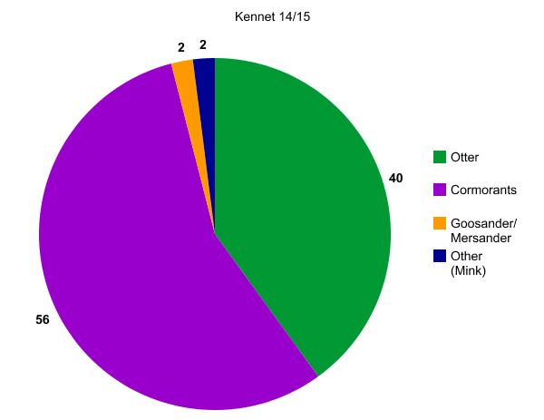](http://nces.ed.gov/nceskids/createagraph/index.asp?ID=04b7b3f529474010950d2ad32b2d461c)

[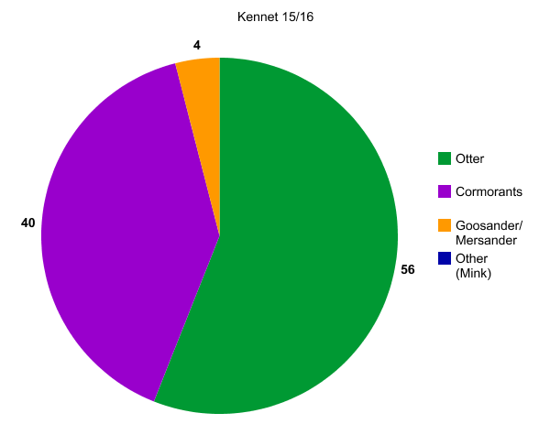](http://nces.ed.gov/nceskids/createagraph/index.asp?ID=2885a62023614206be948a1a9f59b7a2)

[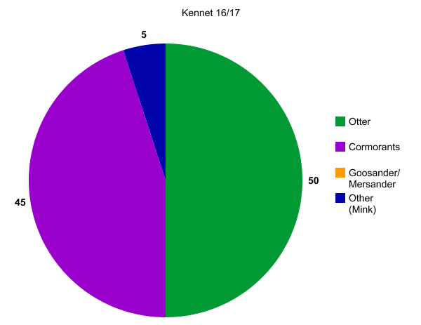](http://nces.ed.gov/nceskids/createagraph/index.asp?ID=ff3f86270d9c4ef68633154cc0730f80)