[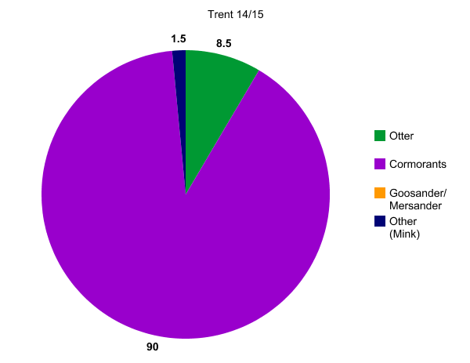](http://nces.ed.gov/nceskids/createagraph/index.asp?ID=df7fa64d81124a599d0eea7db6c72a36)

[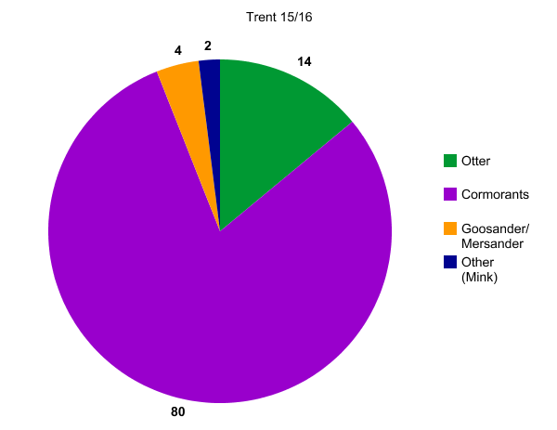](http://nces.ed.gov/nceskids/createagraph/index.asp?ID=c4b68c384c6846298a14467ce2d91ca0)

[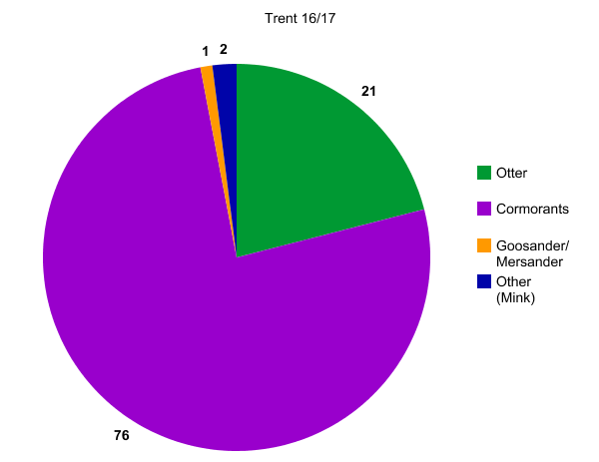](http://nces.ed.gov/nceskids/createagraph/index.asp?ID=96a30c304a2a407e99c718fd21fcab85)