[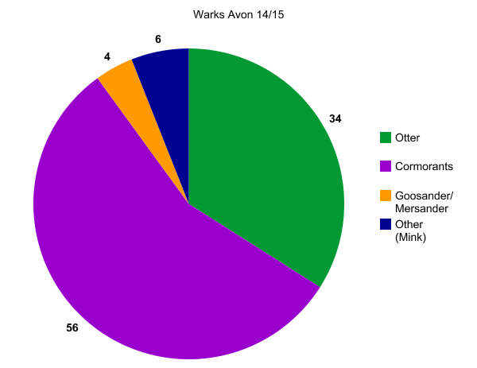](http://nces.ed.gov/nceskids/createagraph/index.asp?ID=3718a511db574968bd7c3c0bda135e7c)

[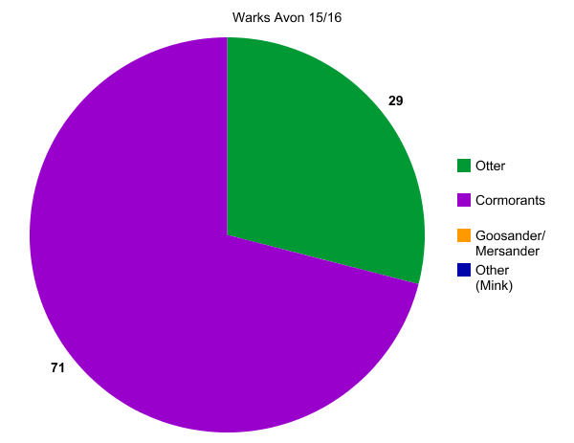](http://nces.ed.gov/nceskids/createagraph/index.asp?ID=b29a77134dd3470aace0b290c8d65bcf)

[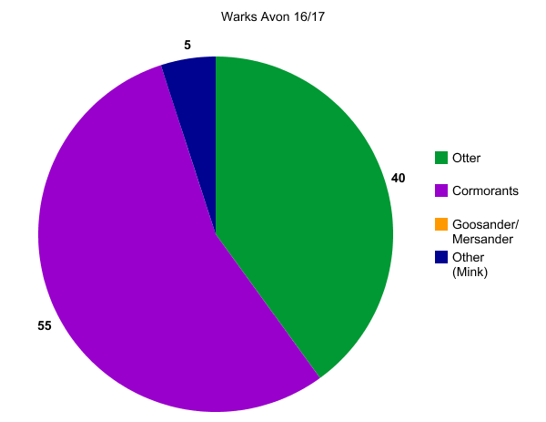](http://nces.ed.gov/nceskids/createagraph/index.asp?ID=c9b06bcb19c54e4186787f1ad4197cf8)