[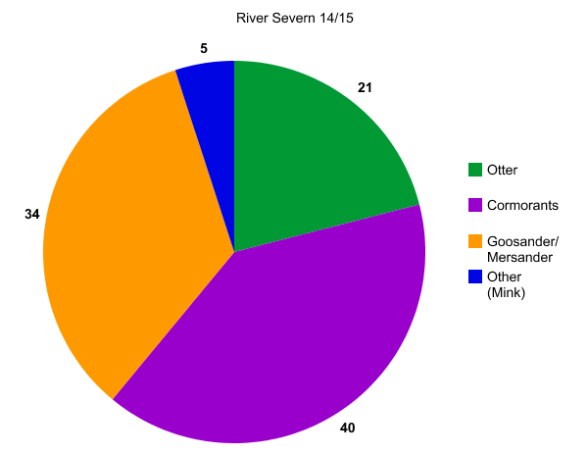](http://nces.ed.gov/nceskids/createagraph/index.asp?ID=8095c8b203044042897ccf522774de94)

[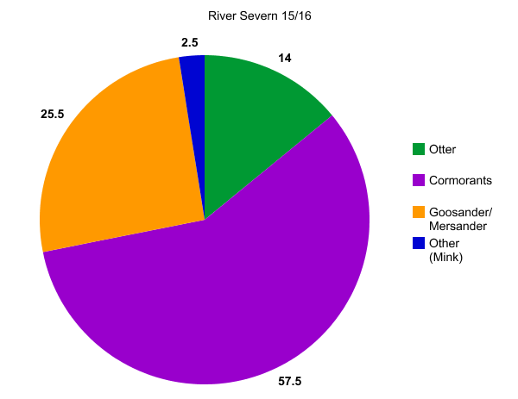](http://nces.ed.gov/nceskids/createagraph/index.asp?ID=9b6c4b39402f4b4b83a5a38b9953d19a)

[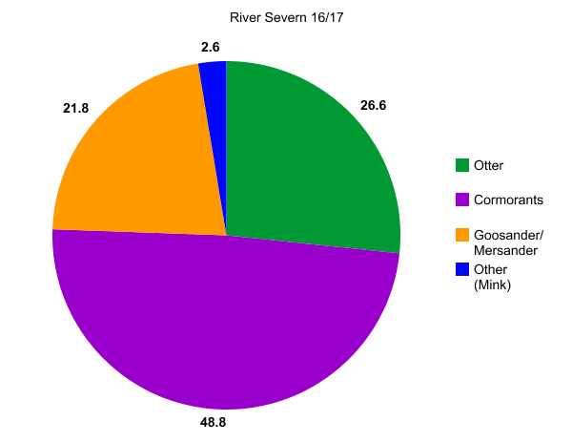](http://nces.ed.gov/nceskids/createagraph/index.asp?ID=4f52065af7424bd180f16f6f7ec3c379)